Mooring Summer Research Report 2022

By: Sarah Turcic

**Methods**

Camera traps were deployed and left to collect data. At a later time, the sd cards were collected (by us or by our Costa Rican contacts). Collected photos were sorted, and all photos that were blank or contained squirrels, mice, birds, or researchers were deleted. Sorted images were then uploaded to WildID, and annotated. The annotation process requires the researcher to identify the type of species present, as well as the number of individuals within the photo. This data is exported as a csv, including all metadata associated with the photo (date, time). This data is compiled to create the master dataset, but for analysis our data is subset into different regions (North, South, Central). I handled the data for northern Costa Rica, which included the Savegre Valley, Copal, Tapanti, and Marta. Camera site and name were combined to form a unique camera station id. There are 116 unique stations within the northern dataset. Within R Studio, data was subset into necessary columns ("Camr_Nm", "Species", "Date", "Time", "Latitud", "Longitd") and all NAs in the date column were removed. If there is more than one record at the same camera station on the same date, the first record is always taken, and the subsequent records are compared to determine if they are independent. If the subsequent records are greater than 24 hrs apart (from the first record and from each other) they are considered independent. Independent records were plotted with the camera station name on the x axis and date (month and year) on the y axis. The number of independent records for each camera during each month/year was included in the corresponding cell. This table was exported as a csv into an excel spreadsheet. From this table, we manually selected a time period with the most cameras running. Each camera in this window was included once, running less than or equal to 4 months, and not necessarily all running at the same time. To abide by the assumptions of a single season single species occupancy model (Mackenzie et al., 2017), the maximum time period we can use for each camera is 4 months. Based on the selected dates, a separate table was manually created to include the start month, start year, end month, and end year for each camera (tw). The main dataset was then filtered via the selected dates for each chosen camera (creating recs_tw). The filtered dataset (recs_tw) was used to create a table including each camera station, and the first and last date each camera was active for (active). This is different from our other table in that it includes the day, month, and year of the first and last active date during the selected period. Our previous table simply included the start and end month and year. This data was used to create a detection table (0’s and 1’s) for each camera on every single day from the earliest time a camera was set to the latest time a camera was stopped. A function was created to collapse records by seven days (comm_hist_maker). Collapsed data is combined to produce our effort table, which indicates the number of days within the seven day collapsed period where the species of interest was observed (value between 0-7). Once records are collapsed (ch_cr_north), we can separate the new records by species, and export this subsetted data to a csv. These exported files include 1 if there is a record, 0 if there is no record but the camera was running, and NA if the camera was not running.

Once the detection table has been created for our species of interest, we now identify and extract site covariate data. A file containing latitude and longitude information for each camera station is created (loc). Latitude and longitude data is converted in R to spatial coordinates (essentially telling R that these numbers are coordinates). Covariate .tif files are imported using the raster function. For this report, we utilized nine covariates (**Table 1**).Data is then extracted from each covariate raster using coordinate data. Extracted data for each covariate is combined and exported as a .csv.

We run our occupancy models utilizing the packaged “unmarked” in R. This model type requires the input of a species detection table, a table of site covariates corresponding to camera station, and a table of survey covariates. Once the required files are imported and checked for the correct data type, we create an unmarkedFrameOccu (umf), and calculate the naive occupancy (does not account for imperfect detection). We next run a null model and run all univariate models. Univariate models are compared to the null model, and if better than the null model (even if not significant) are kept. The covariates from the univariate models which are better than the null model are then used to create multivariate models. This step reduces time spent creating unnecessary models. Once models are created, they are compared based on AIC in order to determine which models are best. The best models are summarized to determine significance, and if significance is found they are then plotted against occupancy or detection probability (depending on the type of covariate) in order to visualize the relationship.

| Covariate: | Description: |
| --- | --- |
| HFI | Human Footprint Index |
| Elevation | Elevation in meters |
| Forest Cover | Forest Cover on a scale of 0-100% |
| Distance to Road | Distance of the camera location to a road in meters. |
| Distance to River | Distance of the camera location to a river in meters. |
| Edge Density | Total density of fragment border to total fragment area in meters^2. |
| Patch Density | ? |
| Disjunct Core | ? |

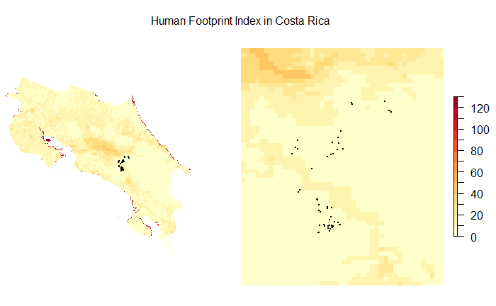

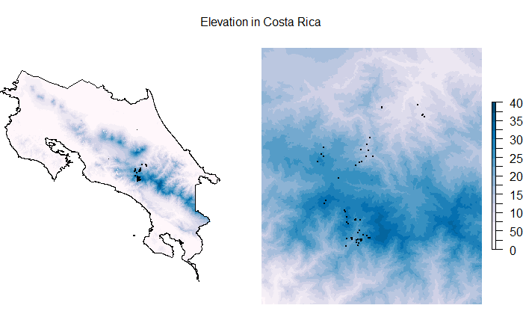

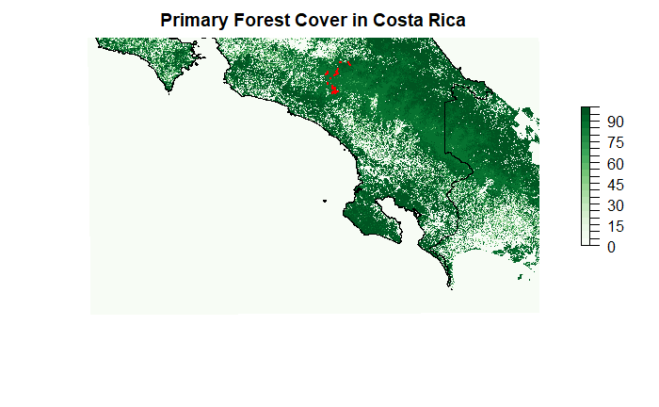

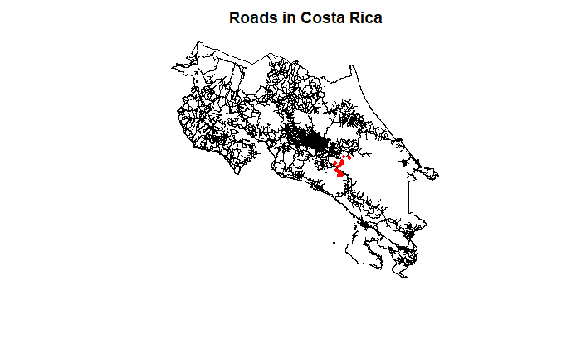

**Results**

Camera site and name were combined to form a unique camera station id. There are 116 unique stations, 31 species, and 7342 independent records within the northern dataset.

Our window of selection for the northern dataset was 4 years (2012-2016) and included 65 cameras, 26 species, and 1322 (recs_tw) independent records.

Our subsetted data contained 11 total Paca observations across 5 total sites, with a maximum of 5 observations at one camera station. For Paca, the calculated naive occupancy was 0.07692308, and while no covariates were significant to paca occupancy, the top models contained covariates: effort, primary productivity, and patch density. A few of the top models did not converge, but the overall top model that did converge contained primary productivity as a covariate.

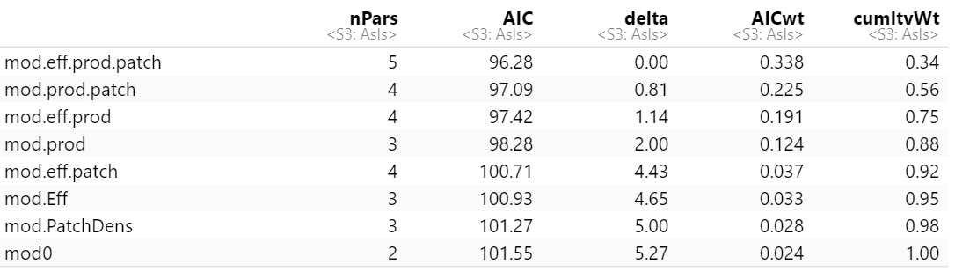

***Table 1:*** Top models for Paca occupancy, ranked by AIC.

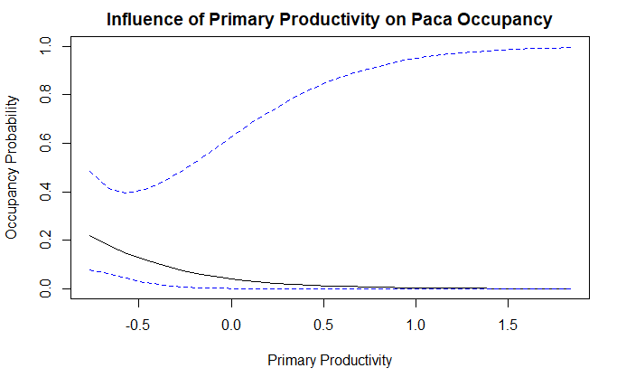

***Figure 1:*** Correlation between primary productivity and paca occupancy probability.

Our subsetted data contained 5 total peccary observations across 5 cameras with a maximum of 1 observation per camera station. For Peccary, the naive occupancy was 0.07692308, and while no covariates were significant to peccary occupancy, the top models contained distance to road and primary productivity. The first four top models did not converge, but the overall top model that did converge contained only primary productivity.

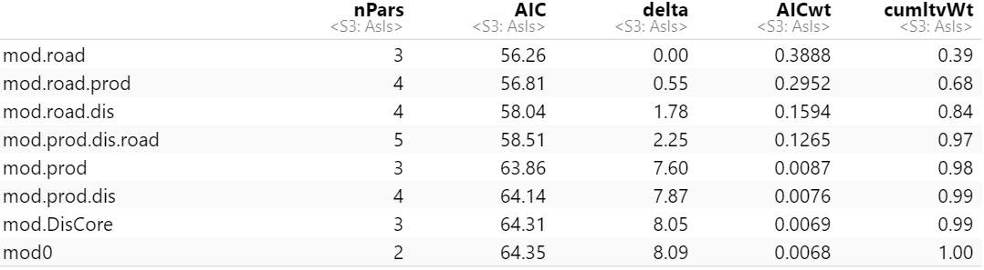

***Table 2:*** Top models for peccary occupancy, ranked by AIC.

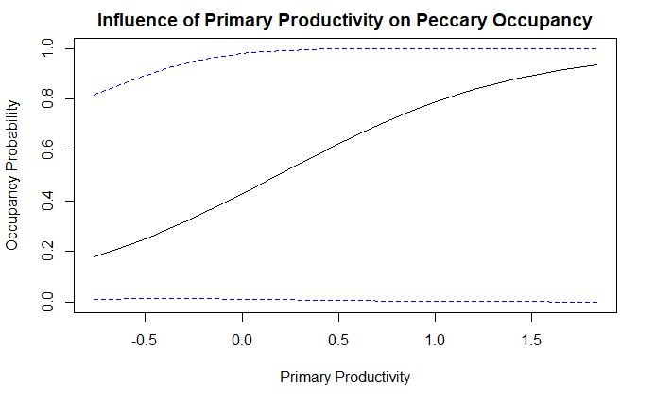

***Figure 2:*** Correlation between primary productivity and peccary occupancy probability.

Our subsetted data contained 8 total puma observations across 8 camera stations, with a maximum of one puma observation at each camera station. For Puma, the calculated naive occupancy is 0.1230769, and while no covariates were significant to puma occupancy, the top models included edge density, human footprint index, distance to core, and forest cover. The top three models did not converge, but the overall top model that did converge contained only distance to core.

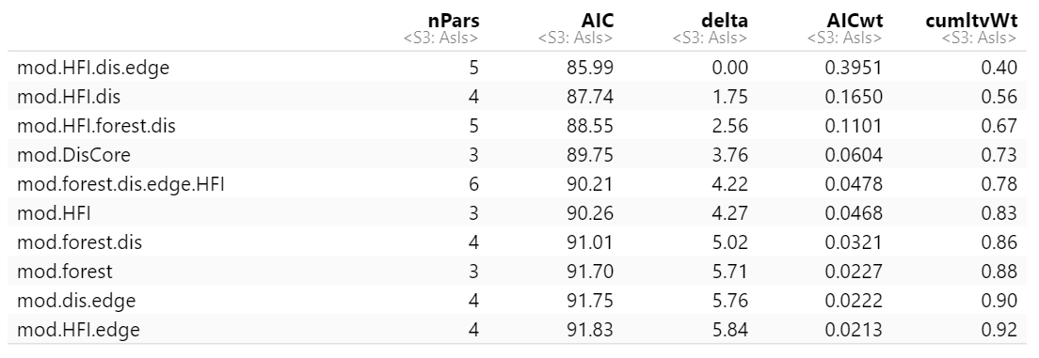

***Table 3:*** Top models for Puma occupancy, ranked by AIC.

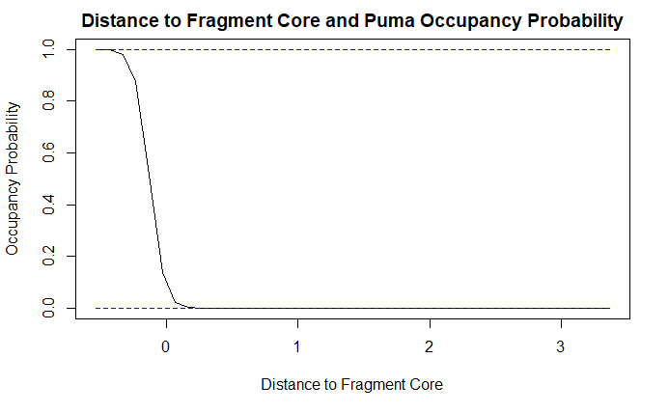

***Figure 3:*** Correlation between distance to fragment core and puma occupancy probability.

Our subsetted data contained 8 total ocelot observations across 5 camera stations, with a maximum of two observations at one camera station. For ocelot, the calculated naive occupancy is 0.07692308, with forest cover as a significant factor to determine ocelot occupancy. The top models contained forest cover, edge density, elevation, and human footprint index. The overall top model contained forest cover and edge density.

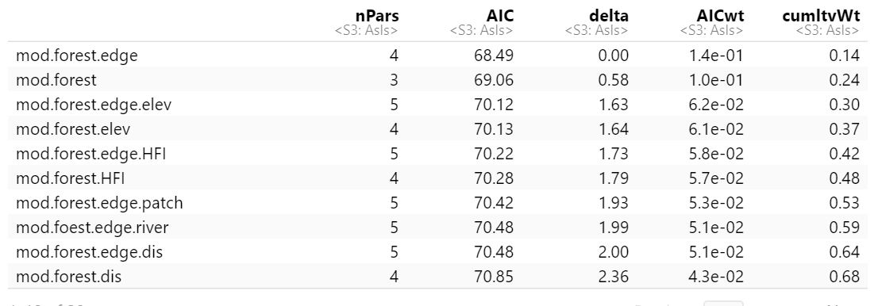

***Table 4:*** Top models for ocelot occupancy, ranked by AIC.

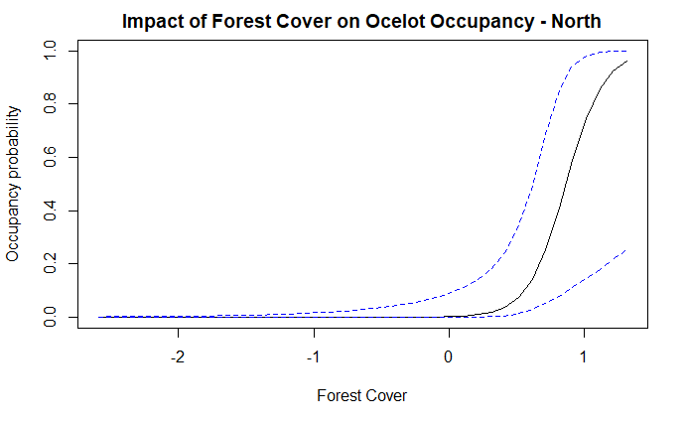

***Figure 4:*** Correlation between forest cover and ocelot occupancy probability.

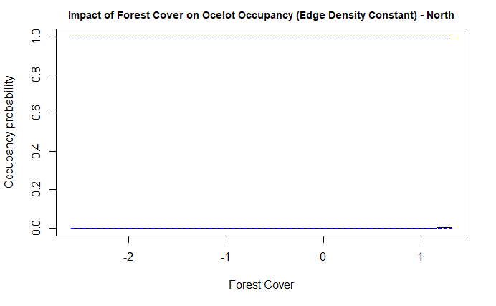

***Figure 5:*** Correlation between forest cover and ocelot occupancy probability with edge density kept constant.

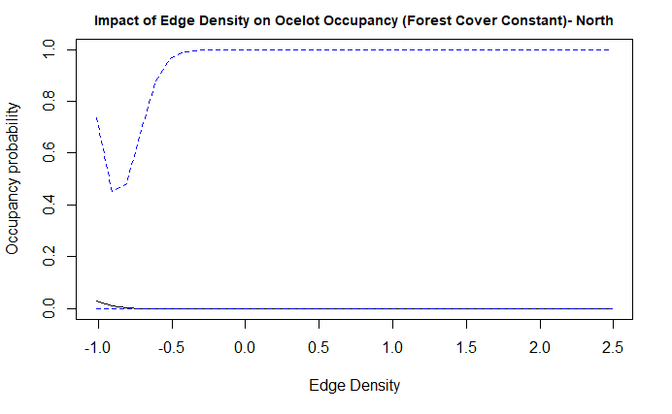

***Figure 6:*** Correlation between edge density and ocelot occupancy with forest cover constant.

Our subsetted data contained a total of 52 Coyote observations across 22 cameras, with a maximum of 5 observations at one camera station. The calculated naive occupancy for Coyote is 0.3384615, with human footprint index and elevation as a significant factor to determine coyote occupancy probability. The overall top model contained human footprint index and elevation.

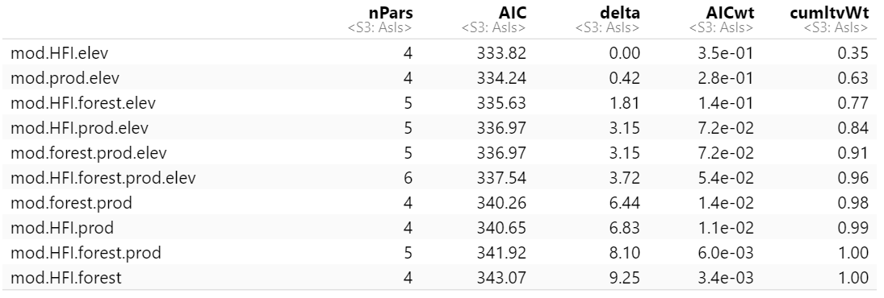

***Table 5:*** Top models for coyote occupancy, ranked by AIC.

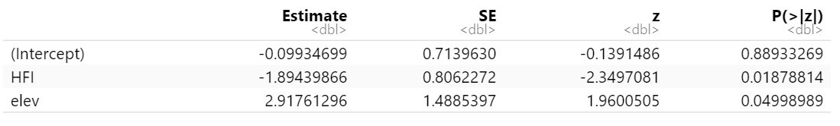

***Table 6:*** Intercept values for the coyote occupancy model, including human footprint index (HFI) and elevation as site covariates.

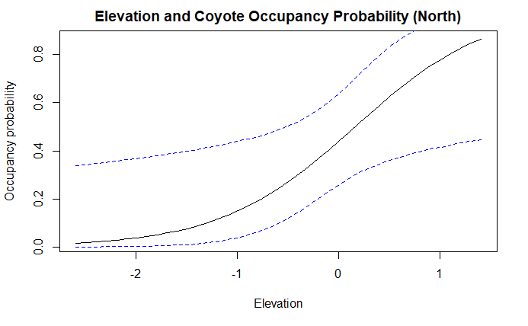

***Figure 7:*** Correlation between elevation and coyote occupancy probability.

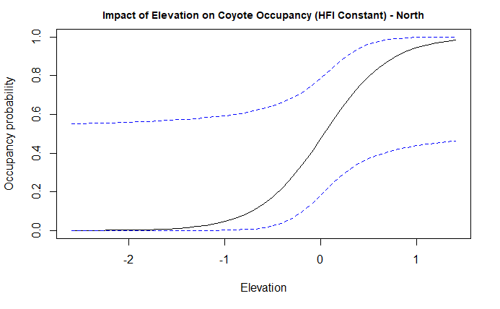

***Figure 8:*** Correlation between elevation coyote occupancy probability with human footprint index kept constant.

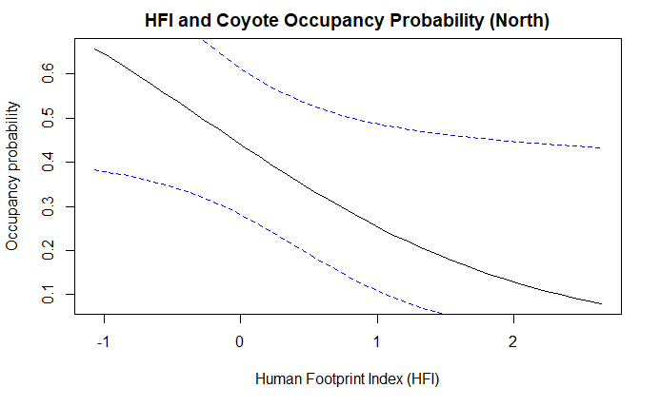

***Figure 9:*** Correlation between human footprint index and coyote occupancy probability.

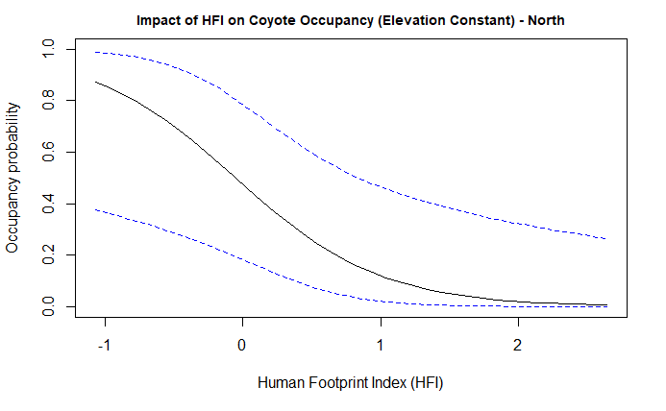

***Figure 10:*** Correlation between human footprint index and coyote occupancy probability with elevation kept constant.

References:

MacKenzie, D. I., Nichols, J. D., Royle, J. A., Pollock, K. H., Bailey, L. L., and Hines, J. E. (2017) Occupancy estimation and modeling: inferring patterns and dynamics of species occurrence. 2nd Edition. Academic Press, Burlington, MA, USA.